Practical 3: Responsive UI Design using CSS Grid, Flexbox, and Bootstrap/Tailwind
Problem Definition: Design responsive layouts for Home, About, Registration, Dashboard, and Events pages using CSS Grid and Flexbox. Optional to use CSS framework such as Bootstrap or Tailwind. Ensure mobile-first responsiveness.
Key Questions:
- How does the layout adapt for mobile, tablet, and desktop screens?
Answer:
- The website uses Bootstrap's responsive grid system to adapt to different screen sizes.
- Mobile: Content is stacked vertically for easy reading and navigation.
- Tablet: Elements are arranged with balanced spacing to make better use of the screen.
- Desktop: Multiple columns are displayed side by side to utilize the larger screen efficiently.
- Bootstrap breakpoints automatically adjust the layout, ensuring a consistent user experience across all devices.

- Which layout technique is used and why?
Answer:
Layout Technique Used: Bootstrap Grid System (Flexbox)
- Creates a responsive layout that works on all screen sizes.
- Divides the page into a 12-column grid, making content organization easier.
- Flexbox provides flexible alignment and spacing of elements.
- Reduces the need for writing complex CSS.
- Makes the website easier to maintain and update.
- Are typography, spacing, colors, and contrast readable?
Answer:
Yes. The project follows good UI and readability practices:
- Typography: Uses clear and readable font sizes with proper font hierarchy.
- Spacing: Appropriate margins and padding are used to avoid a cluttered interface.
- Colors: A consistent color scheme is maintained throughout the website.
- Contrast: Good contrast between text and background improves readability.
- Accessibility: The design is comfortable to read on different devices and screen sizes.
These elements together improve the overall user experience and make the interface visually appealing.

- Is the framework used consistently without unnecessary inline CSS?
Answer:
Yes. The project uses Bootstrap consistently throughout the website.
- Bootstrap classes are used for layout, buttons, forms, navigation, and responsive design.
- Most styling is achieved using Bootstrap's built-in utility classes.
- Custom styles, if required, are placed in an external CSS file instead of inline CSS.
- Unnecessary inline CSS is avoided, making the code cleaner and easier to maintain.
- This approach improves code reusability, readability, and simplifies future modifications.

For Codes: https://github.com/kunjborad21/WebDev-CSE1-A/tree/main/Practical%203

Webpages:
1. Home page:
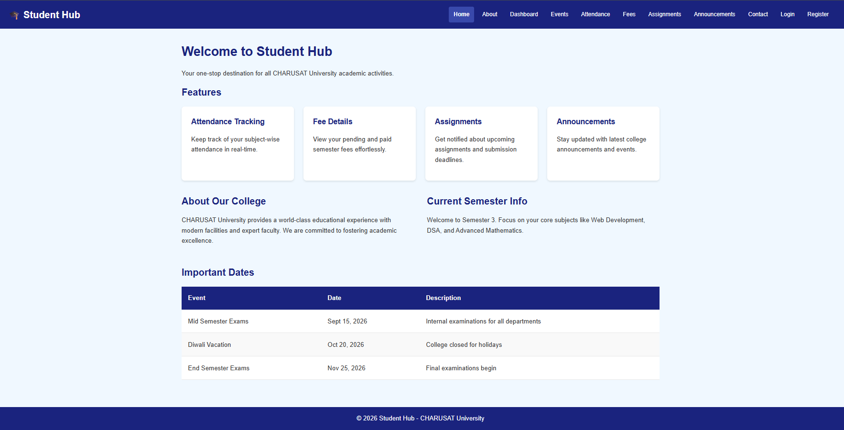

2. About page:

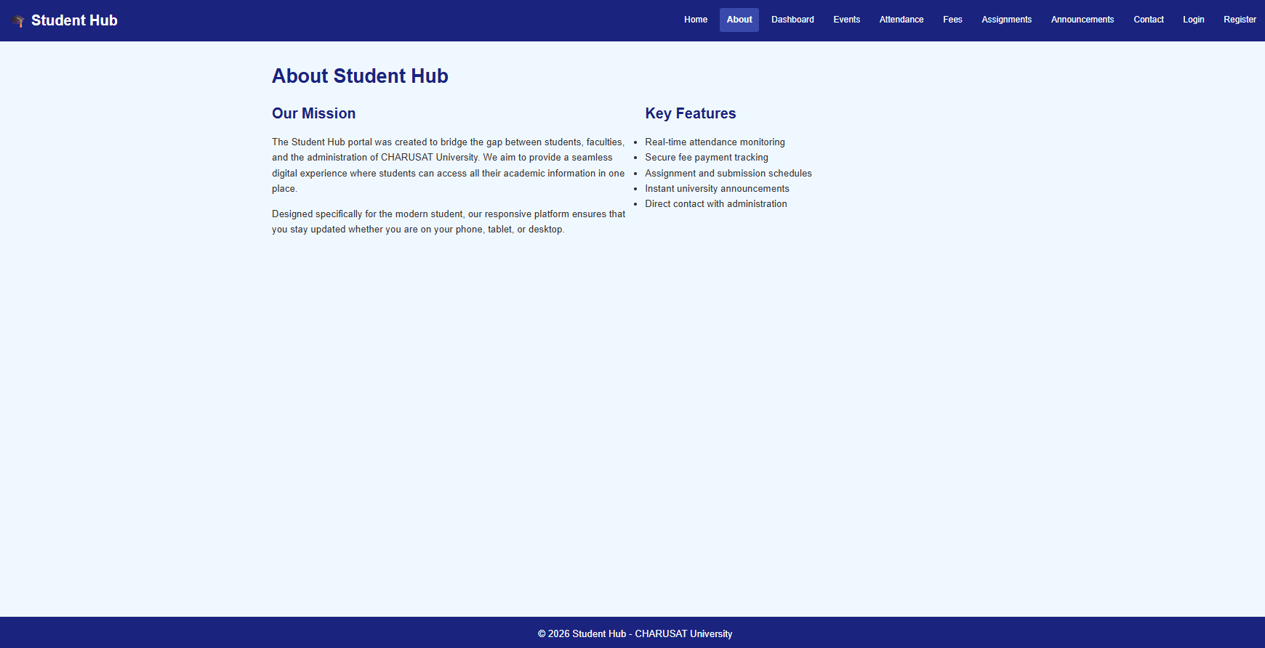

3. Dashboard page:

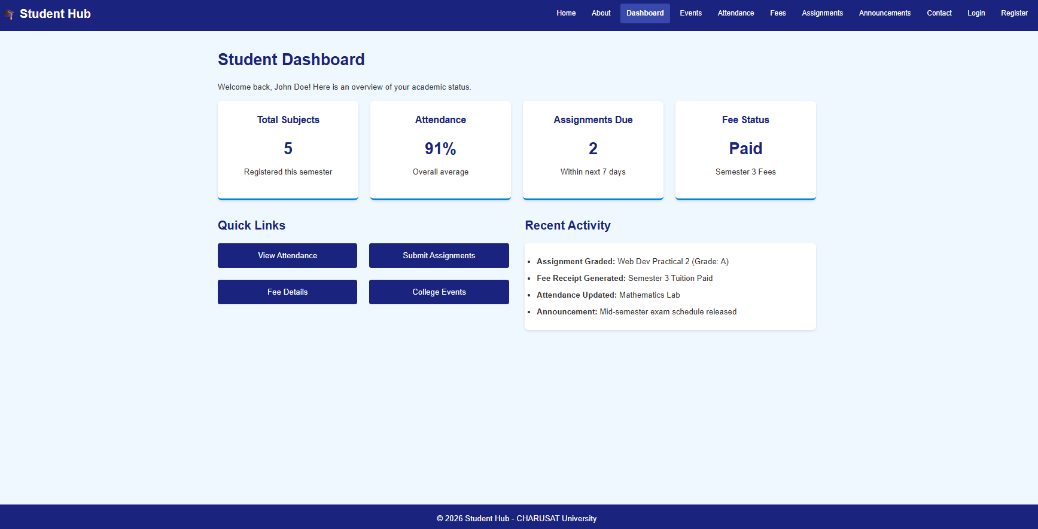

4. Event page:

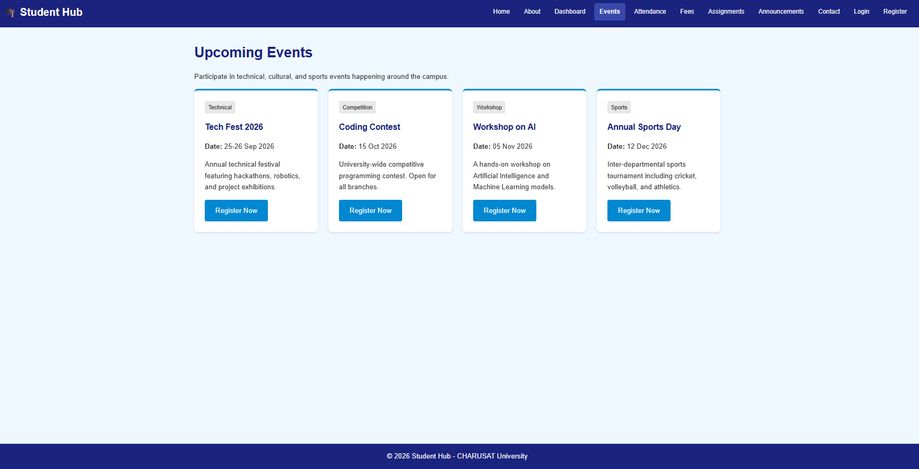

5. Attendance page:

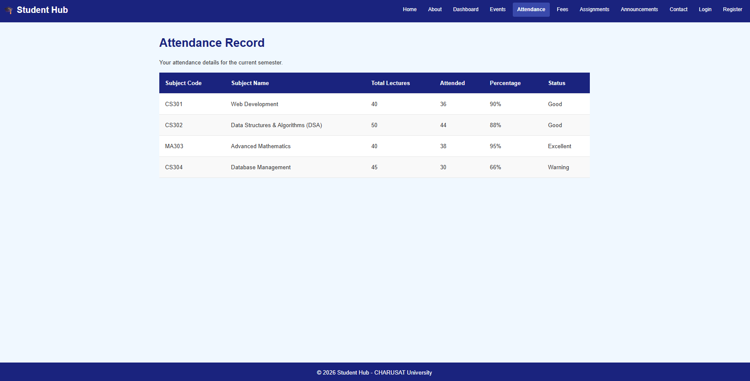

6. Fees page:

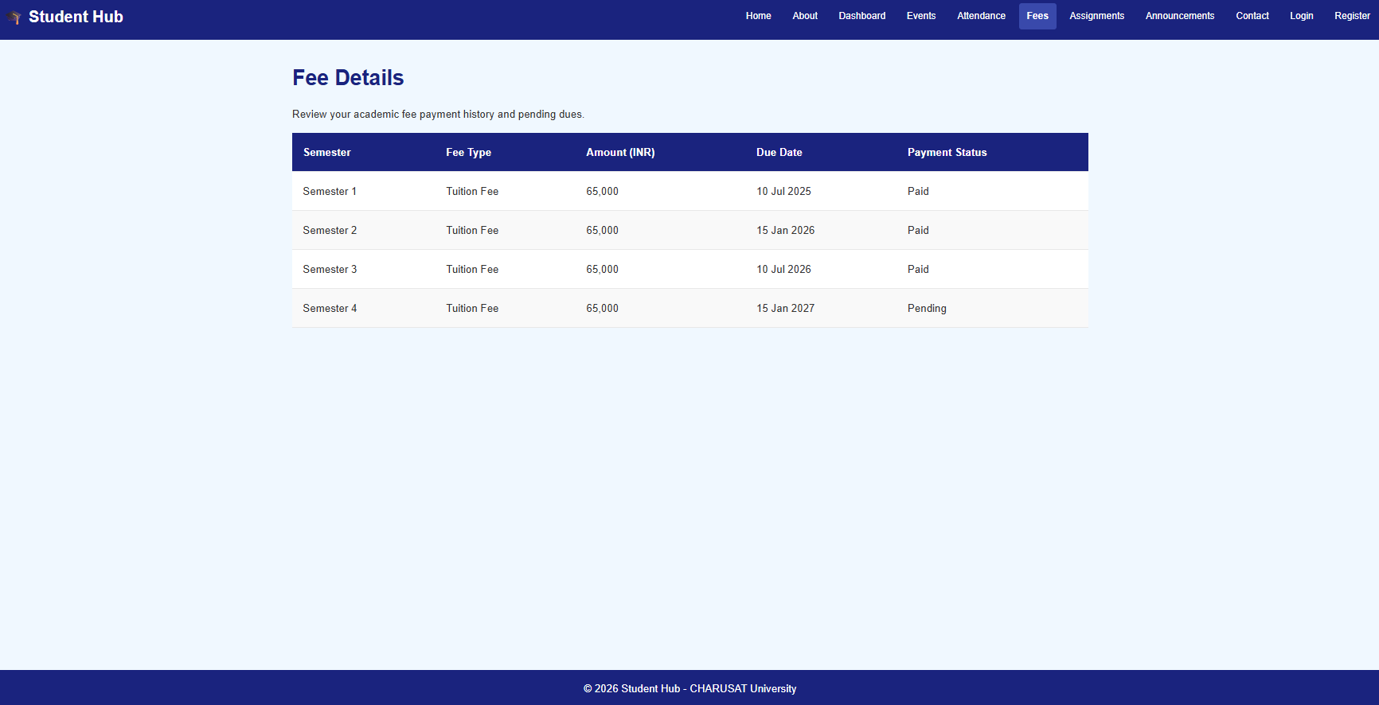

7. Assignments page:

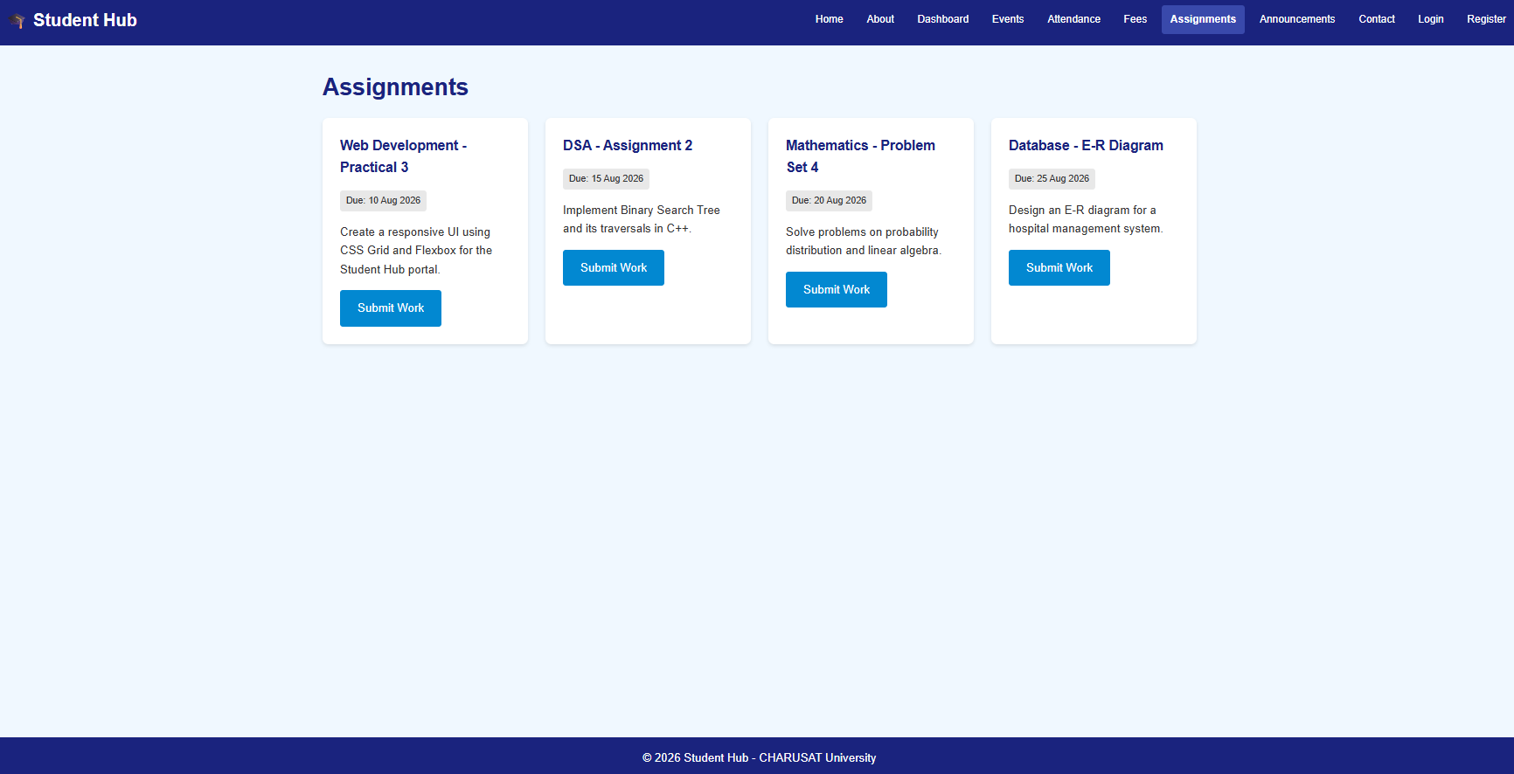

8. Announcements page:

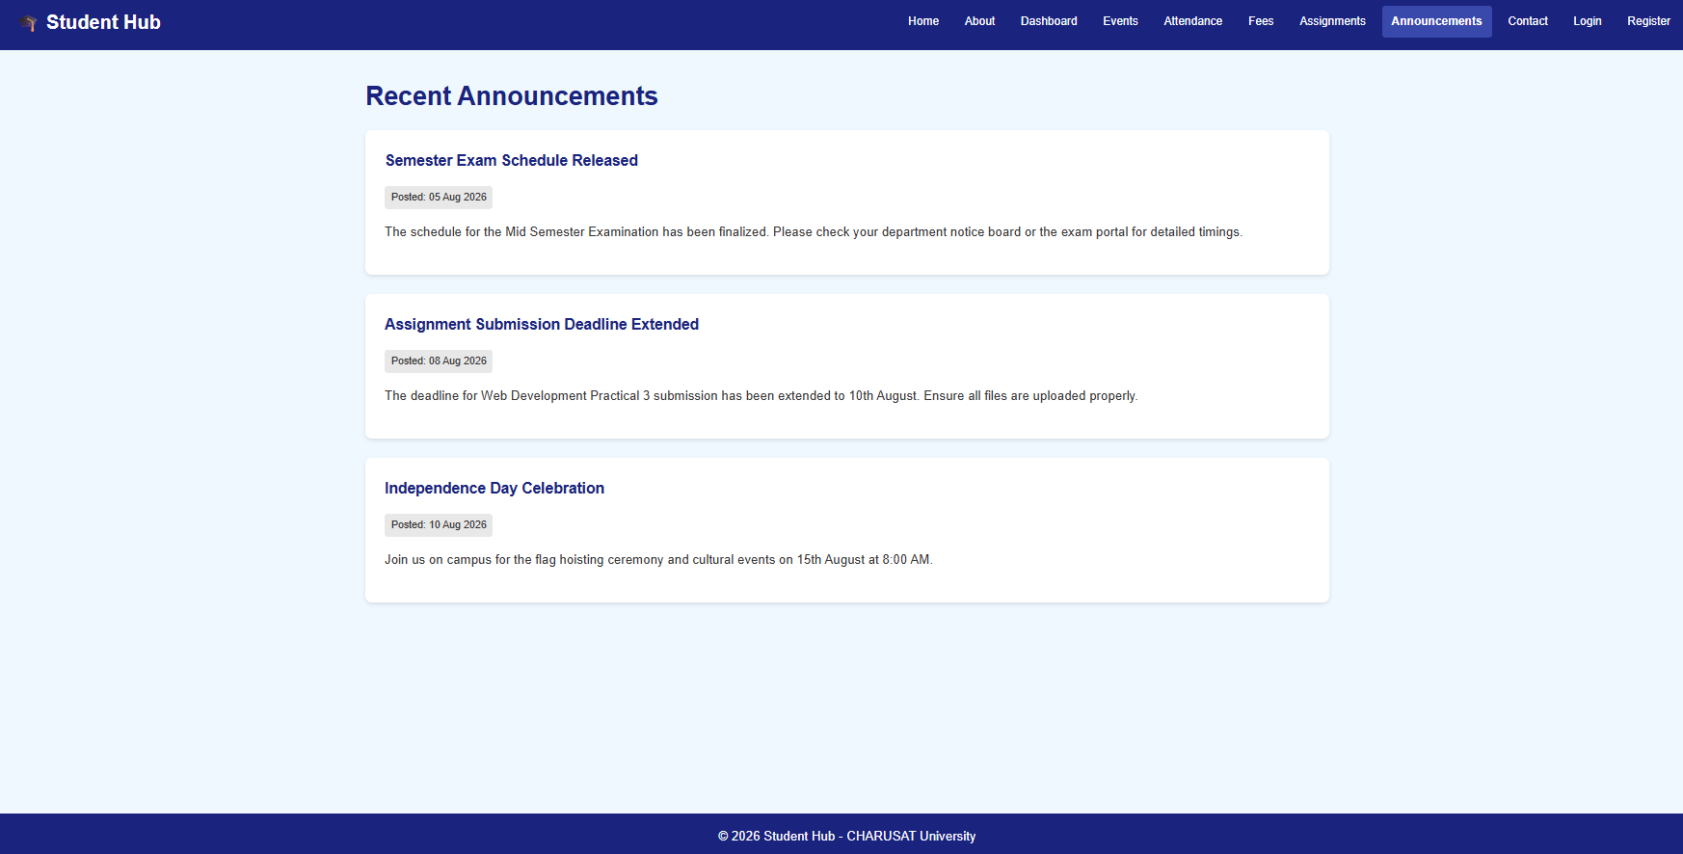

9. Contact page:

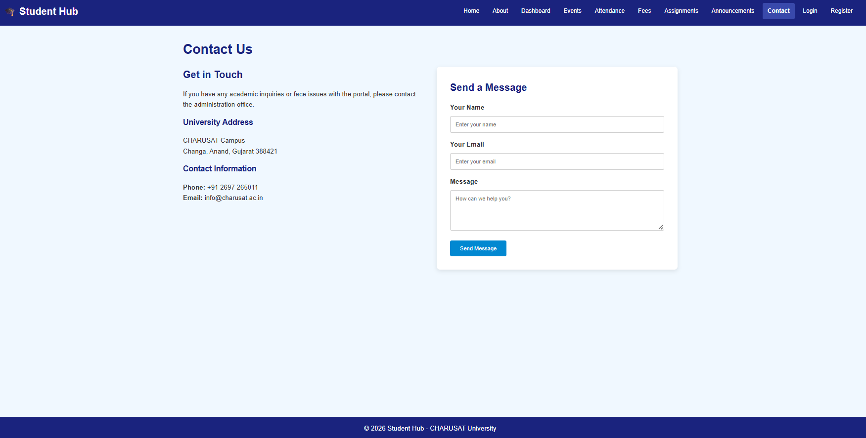

10. Login page:

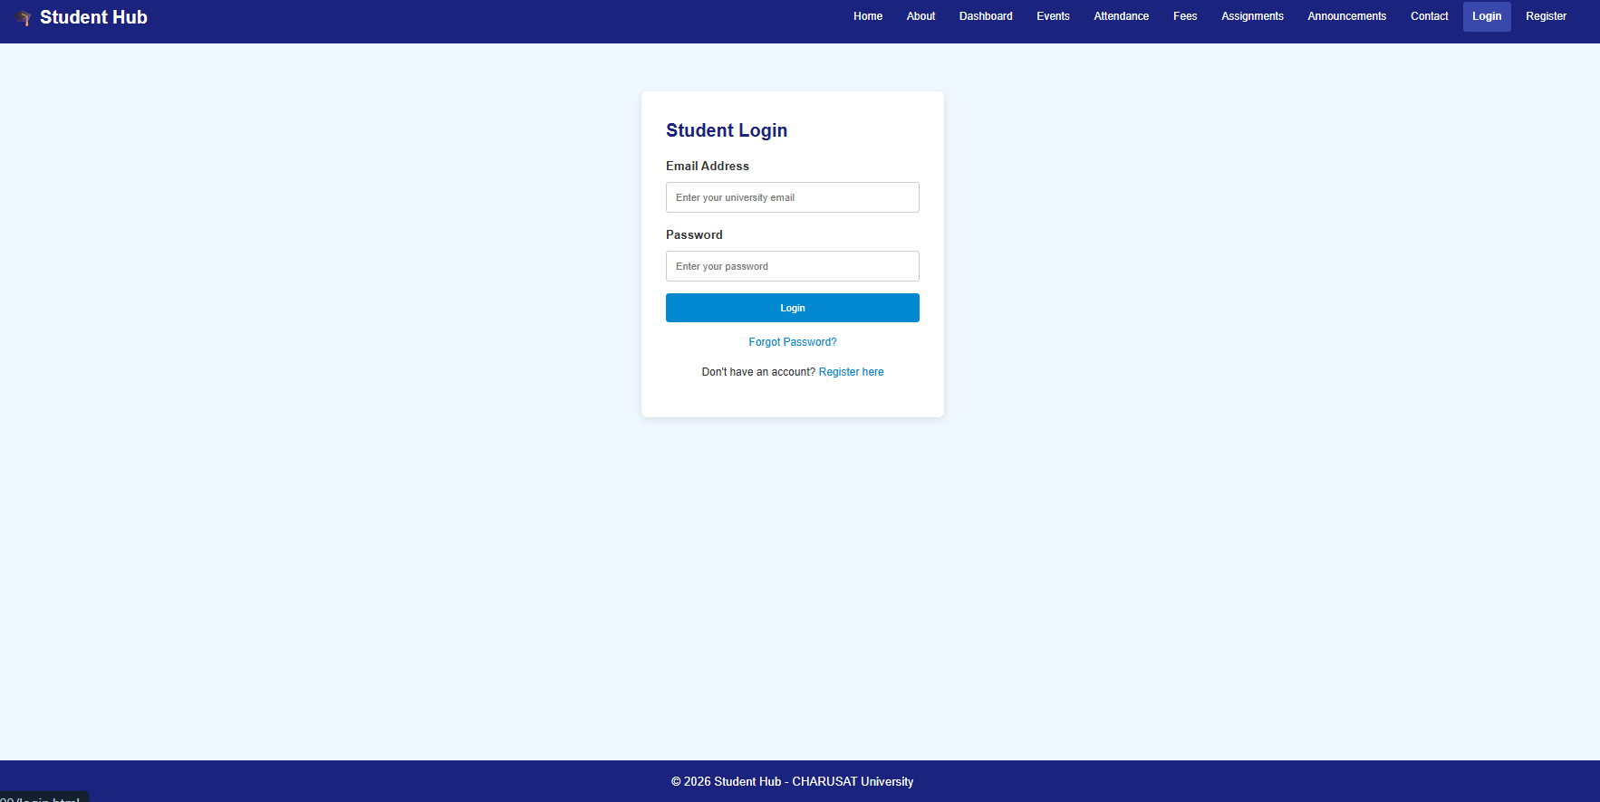

11. Forget password page:

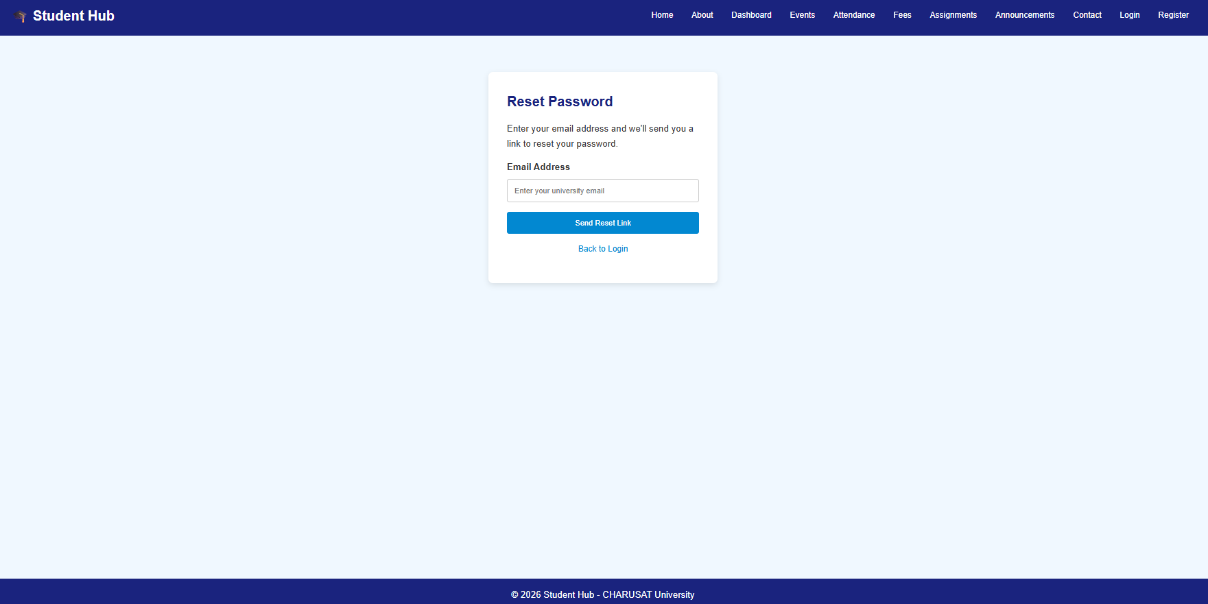

12. Register page:

